Games Development Pipeline

Rube Goldberg machine

Assignment Report

Aaron Carry

The first thing that I had to create was my plan for how I wanted the machine to look and plan whether or not this would actually work the way that I planned, this included deciding on which devices I wanted to be present in my machine.

The first device fetched in my machine is the starting ball and a series of ramps, the ball is effected by gravity and rolls down the ramps there were 2 reasons why I decided to have them in my scene one there appear in almost every machine so they are somewhat of a staple and the second being that they appear commonly in the game Mario 64 which is what I themed my machine off this is by far this simplest device I have in my scene,

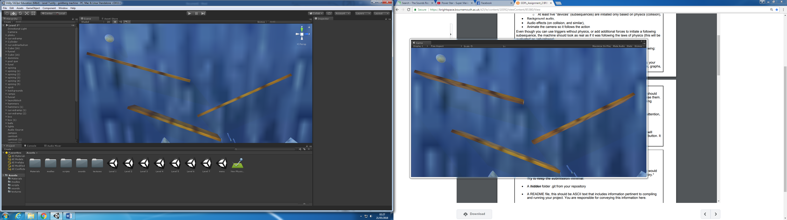

The second device I have in my scene is a plink-o like section were a ball drops down and bounces off multiple protruding pools I thought this was an interesting way to transition between different devices rather than just having a straight drop.

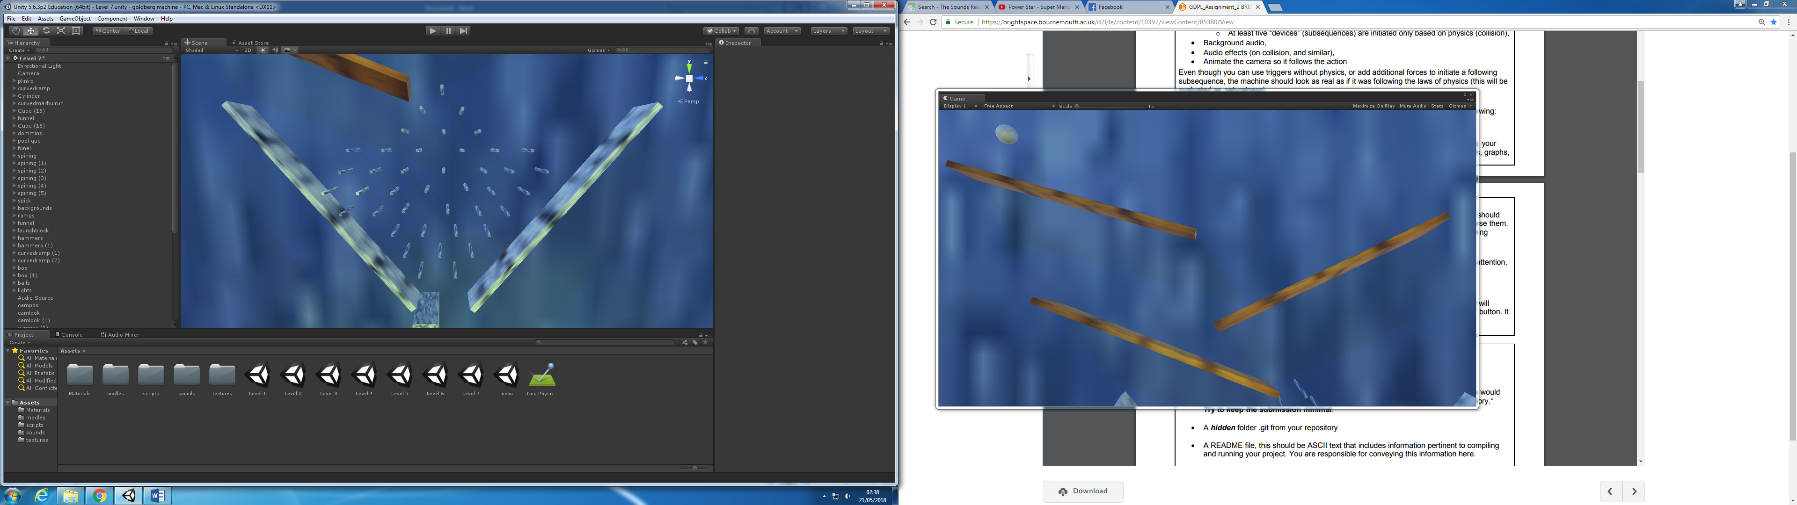

Next I have my ball roll down a curved ramp to then collided with a hammer that then swings down and starts the next device this was chosen as hammers are often theatre in the Mario world so I thought it would fit nicely plus the hammer is operated by gravity so it doesn’t require any coding and is very affective.

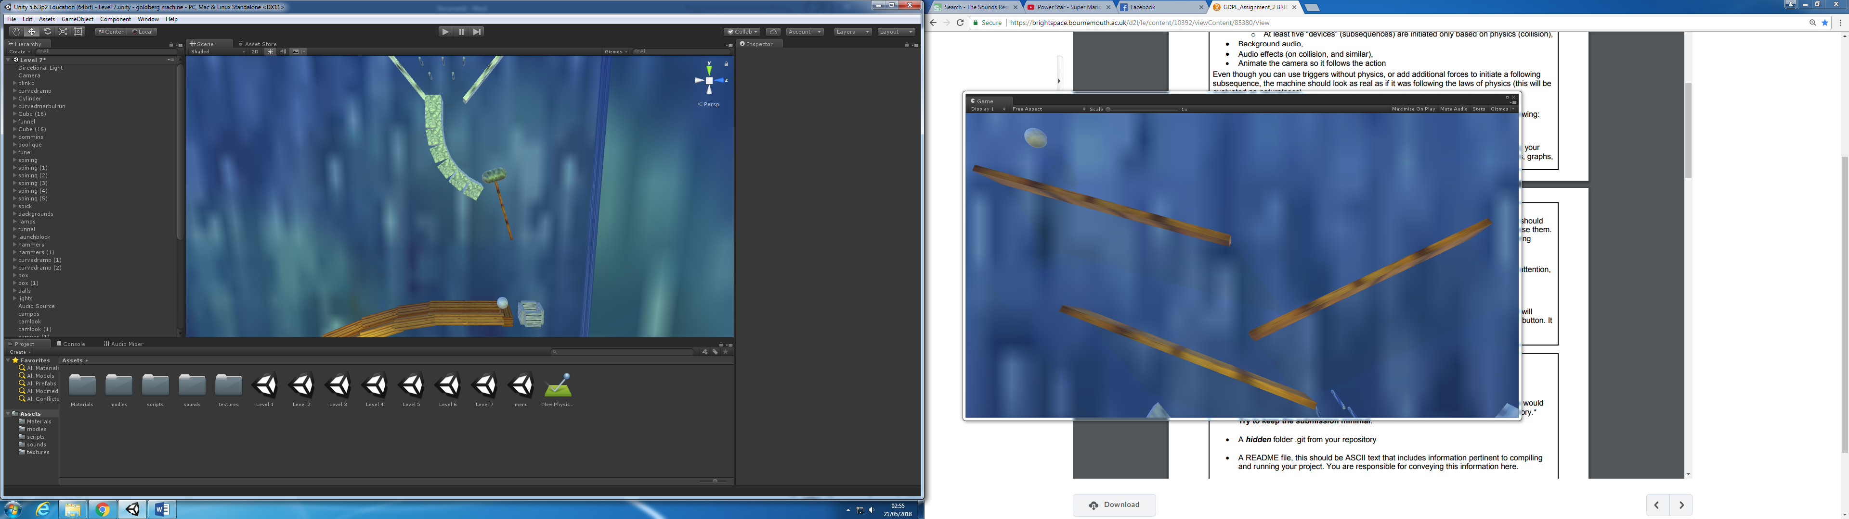

Once the hammer swings down it hits a second all and the first ball falls into a box to stop it from interfering with any further devices the second ball then runs down a slope into a funnel, that then lets the ball drop into without it flying off course with the memento its built up, this funnel then feeds the ball into the next device

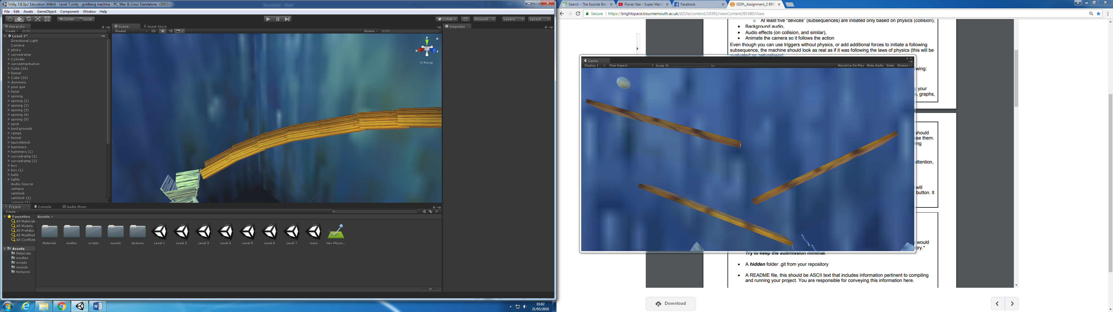

From the funnel the ball is then dropped into a box this box is triggered by the presence of a ball within it this then courses the box to move a set direction, speed and distance as set by the code within the boxes trigger I use this to move the box to a new location and to tip the box once it reaches a set distance this courses the ball to then roll out into the next device, the floating platform or in this case box idea came from once age Mario 64 as floating platforms are a staple in the game so it felt fitting to include them.

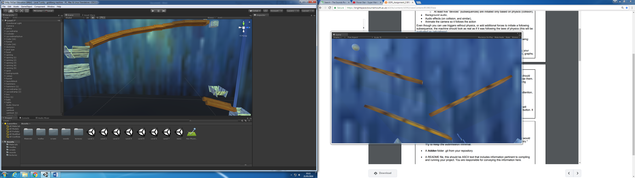

The ball is tipped into a second funnel were it runs down a second run way and into another floating box this one however lifts the ball into the air,

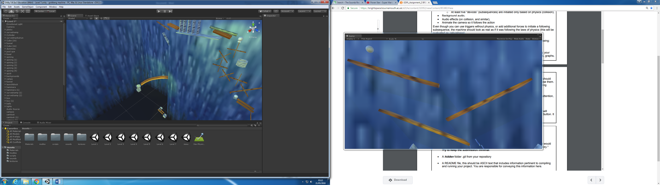

The third ball is then sent down a ramp into a series of dominos these are all balanced perfectly so that they are triggered by any force applied to them in this case the ball rolling down a ramp and colliding with them the dominos then fall and trigger the next event

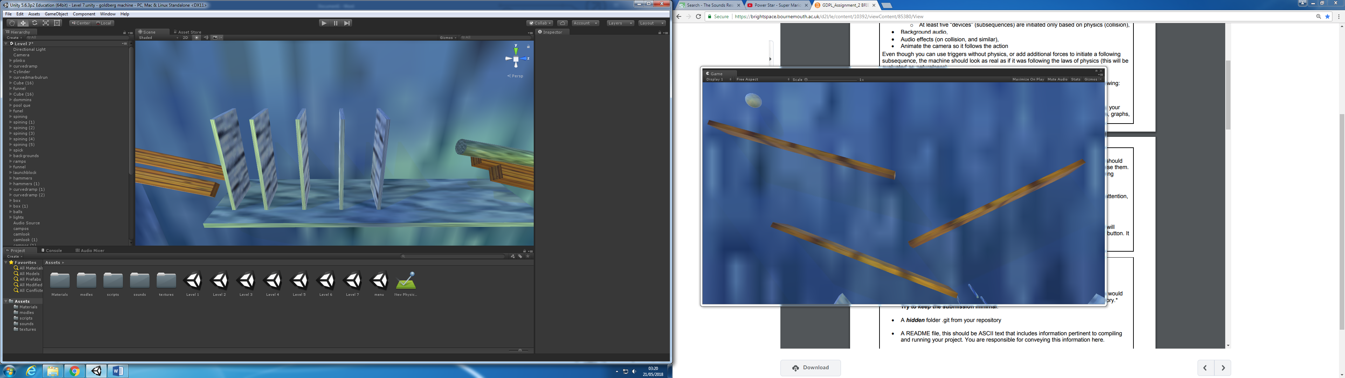

Once the dominoes fall they hit what I call the pool que this works like a que in pool (unsurprisingly) a cylinder that is affected by gravity is supported by two blocks that are tilted at an angle to provide a clear guide for where the que is to go this out the blocks the que would just fall with the gravity and without the gravity the que would be unaffected by the dominoes the que slides alone the gap in the blocks and activates the next device.

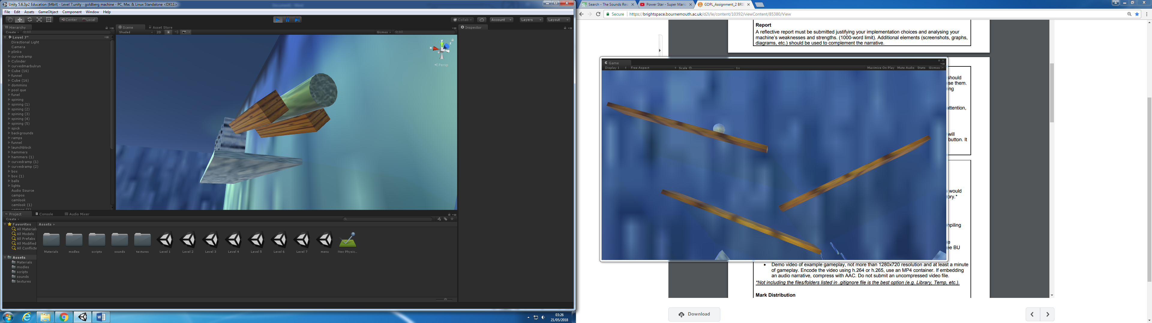

The que then slides forward and hits a forth ball which rolls of a ledge into the next device

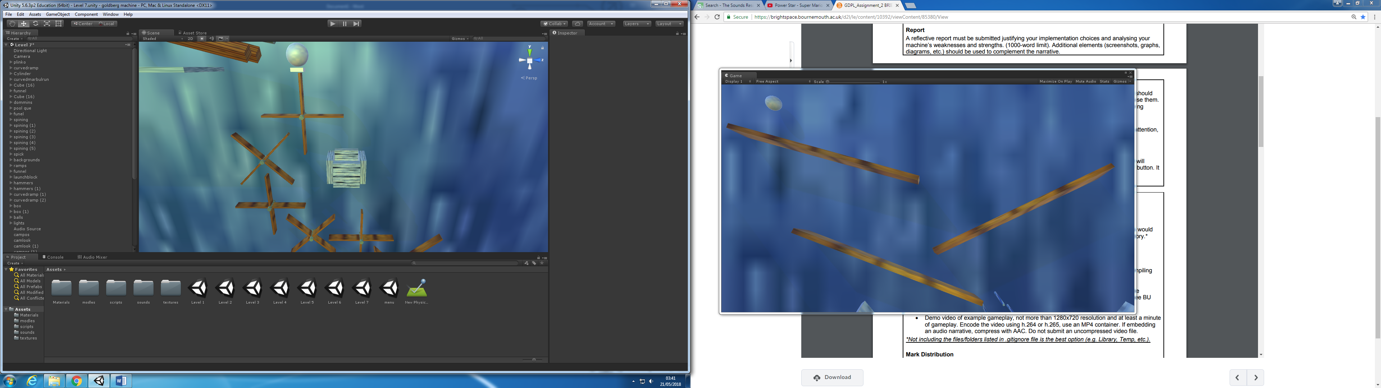

The all then triggers a series of spinning plate forms that activate each over once one is hit once the ball has hit the first of the spinners it rolls of and is caught by a box to prevent it from falling and getting stuck in the rest of the spinners which happened a few times in the development of this section.



The final gear in this series is different because is scoops up a fifth ball and pulls it for its stationary position into the next device

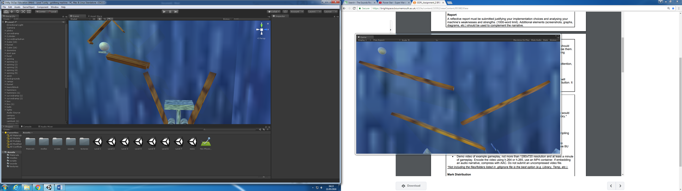

The ball then run downs a run ways sloop into a hole with a wedge like device resting at the bottom of it once the ball lands on top of it, it is driven down to activate the next device the wedge consists of two parts one that runs down and sets off the next dives and one that runs alone top and makes sure that stops the bottom part from falling forever and potentially damaging the rest of the machine, this is a potential risk because the wedge is a ridge body but isn’t effected by gravity so without a support it will fall forever.

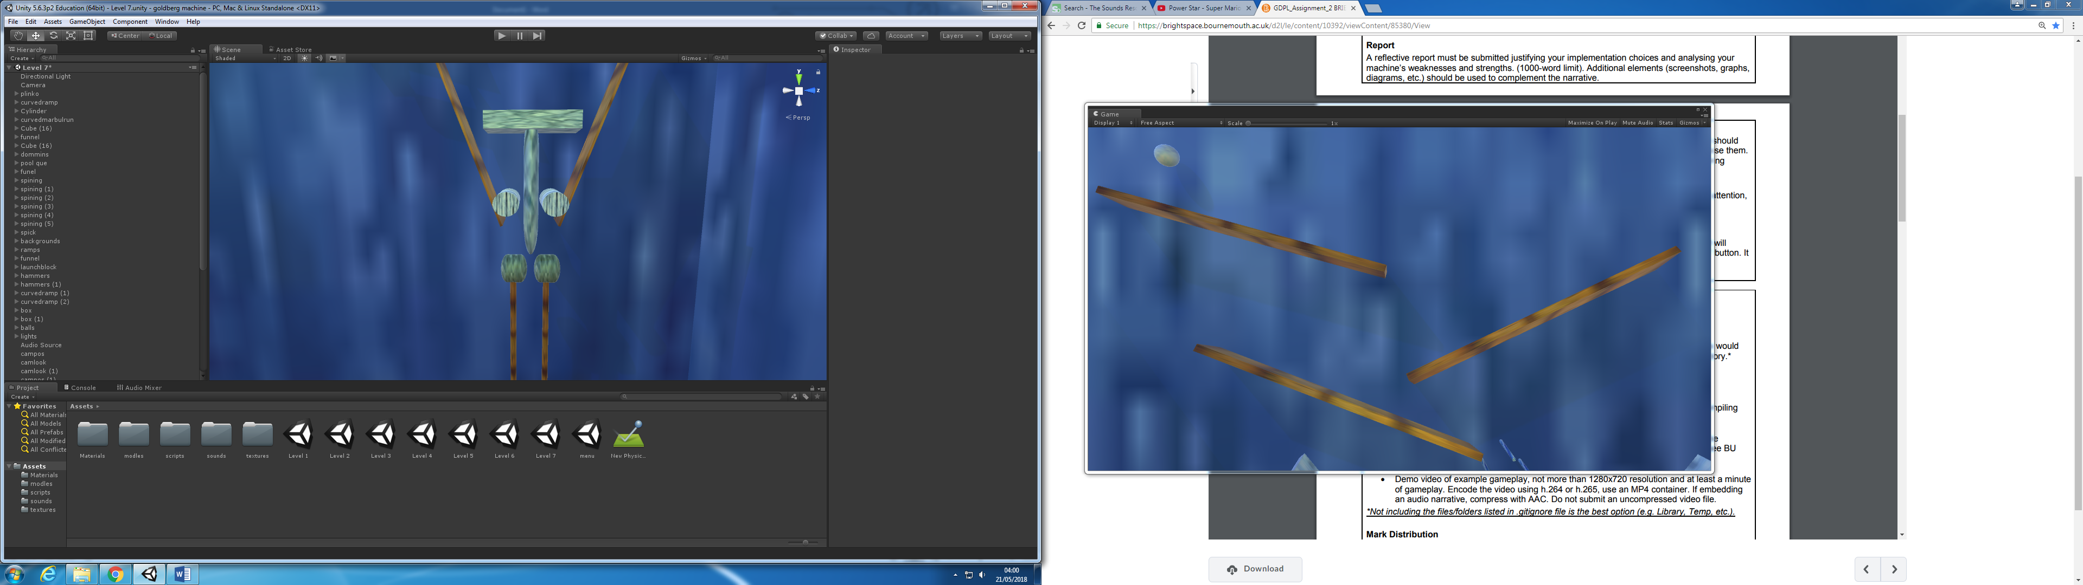

The bottom half of the wedge connects with two hammers simultaneously causing both to start swinging by them self which then swing down and collide with a sixth and final ball ether one of these hammers may move the ball starting the last device.

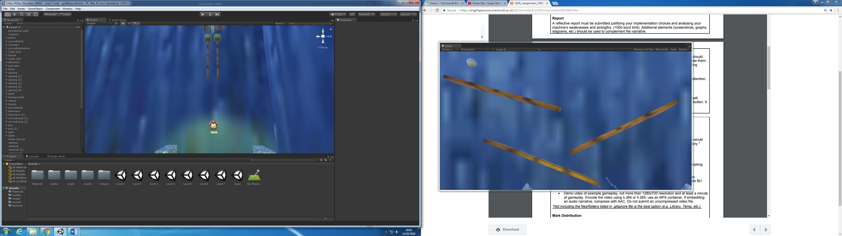

Once the ball is hit by ether the left or right hammer it will fall in the opposite direction to the hammer that hit it were it is caught by a half pipe like ramp that the ball rolls down into a final holder on the way down it collides with a Mario power star that disappears after contact with the ball signifying that it has been collected like in Mario 64 this plays a sound effect and returns you to the start menu.

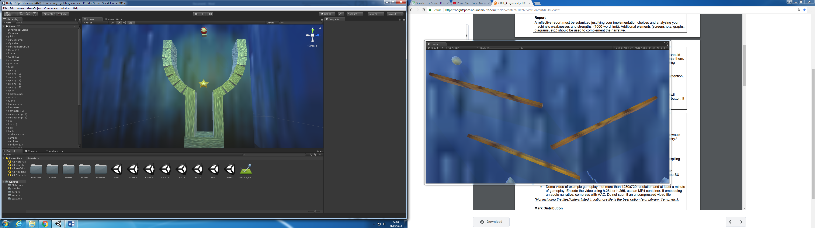

Reference

(Textures-resource.com, 2018)

Textures-resource.com. (2018). Nintendo 64 - Super Mario 64 - Cool Cool Mountain - The Textures Resource. [online] Available at: https://www.textures-resource.com/nintendo_64/mario64/texture/1204/ [Accessed 21 May 2018].

(Textures-resource.com, 2018)

Textures-resource.com. (2018). Wii - Super Mario Galaxy - Mario - The Textures Resource. [online] Available at: https://www.textures-resource.com/wii/mariogalaxy/texture/4897/ [Accessed 21 May 2018].

(YouTube, 2018)

YouTube. (2018). Power Star - Super Mario 64. [online] Available at: https://www.youtube.com/watch?v=1HdlGxUc0rM [Accessed 21 May 2018].

(YouTube, 2018)

YouTube. (2018). Slide - Super Mario 64. [online] Available at: https://www.youtube.com/watch?v=_sG5YwPtetk [Accessed 21 May 2018].

(Models-resource.com, 2018)

Models-resource.com. (2018). DS / DSi - Super Mario 64 DS - Star - The Models Resource. [online] Available at: https://www.models-resource.com/ds_dsi/supermario64ds/model/22829/ [Accessed 21 May 2018].